Tulip Medical
Quality System Procedure
QSP 4.2-1
Document Control

Approvals

V.P Regulatory Affairs Date

Regulatory Affairs Coordinator Date

Document Control Administrator Date

Rev | Date | Description of Change
1 | 09/23/2014 | Updated external and internal document control and website control.
2 | 07/09/2015 | Updated website controls and use of Change Request Form (4.2-1-2).
3 | 10/19/2017 | ISO 13485 updated to 2012 edition. Reference documents updated. Process updated to reflect current procedure in place and functions responsible. Appendix B, the Approval Authority Breakdown, added to simplify understanding of which positions are approved to sign off on specific documents.
4 | 04/23/2018 | Inclusion of 7.4.6, which specifies who is authorized to supply Production with forms.
5 | 08/28/2018 | Sections 1.0, 7.4.6, 7.5.2, 7.6, 7.6.1, 7.11.1, 7.12.1, 7.14.2 and Appendix B updated as required by ISO 13485:2016.
6 | 08/23/2019 | Reference Section updated with QSP 4.2-6 Website Management. Sections 7.7-1 Revised to include instructions for Website Management and QSP 4.2-6. Section 7.11 External Documents links updated. Re-formatted Flowchart.
7 | 09/26/2019 | Revised Section 2.0 Scope – added Work Instructions  Section 4.0 Definitions – revised second paragraph to read master files and original signed and dated  Section 7.1, 7.1.4; Section 7.4 Document Control of Non-Product-Specific Procedures and Forms, 7.4.2; 7.4.4.2; and 7.4.5 revised to master files binder  Section 7.5 Document Control of Product-Specific Documents That Form the Device Master Record, 7.5.3 revised how a word document is stored  Section 7.5, 7.5.5 added who maintains the master files  Section 7.6 Document Control of Technical Files, Declarations of Conformity, Risk Management documents, Medical Device File and Clinical Evaluation, 7.6.1 revised to read Master Files; 7.4.6 revised who can print copies of forms  Section 7.12 Training as Follow-up to Document Control Changes, 7.12.1 revised to read manual  Appendix B, II All Quality Documents – Approval Matrix – added cT, R, D to Production for the Work Instructions and Records (RFD, forms, tags charts)
8 | 10/16/2019 | Added a Section II to Appendix B. Section II provides clarity on who has Controlled Document read/write capabilities. This section restricts the access needed to make changes to controlled documents to that of RA/QA/MR, Production and Inventory Control, and Documents Control. Removed invalid flowchart in section 8.0. Removed inaccurate links to regulatory bodies.
9 | 3/22/2023 | Added Section 7.1 in accordance with IS) 13485:2016 Clause 4.2.4 a - h
10 | 03/14/2025 | Addition of Regulatory Affairs approval signatures  3.0 Reference Documents –  - Revised ISO 13485:2012 to ISO 13485:2016  - Update Form 4.2-1-1 to Form 4.2-4-1-L  - Added Form 4.2-1-3 Document Review Checklist.  5.0 Update abbreviation DCL Document Control List to DCL – Document Control Log and thorough all document  7.2. Rephrased and restructured  7.3 Addition of a Procedure for Document Review Checklist  7.6.3 Removed Dropbox and replaced it with Google Drive  7.8.1 Update COO to EVP  7.12.3 Update Emergo to MedEnvoy  7.16 Addition of Procedure for approved documents  8.0 Implemented Flowchart  Appendix B Updated
11 | 04/03/2025 | 5.0 Added abbreviation DCA  6.0 Changed from All Employees to Document Control Administrator  7.12.1 Added DCA to responsible with MR  7.13.1 Updated from MR to DCA  7.15.2 Updated from MR to DCA
12 | 5/23/2025 | 3.0 Updated to MDR Regulation from MDD  -Added QSP 7.3-1 as mentioned in the procedures  -Corrected QSP number for Risk Management  7.7.1 Added reference location of the MDR  7.12.3 Changed to EU MDR From MDD
13 | 08/07/2025 | Removed MR from QSP  5.0 Added VPRA - Vice President of Regulatory Affairs to the abbreviation and throughout the QSP  6.0 Added VP of Regulatory Affairs to responsibilities.  7.3.1 Updated to mandate Form 4.2-1-3 with all revisions to be included with the change record  Updated Appendix A to include Australia (Sponsor), BRH (Brazil), and MAH (Japan)

- PURPOSE
This section describes how Tulip Medical controls required Quality System documents and our website. These controls ensure personnel have access to the latest revisions of controlled documents they need to do their jobs. Such controlled documents include, but may not be limited to, procedures, forms, the Quality Manual, labeling, information on the website, product drawings and specifications, and external documents such as ISO 13485:2016.
This procedure assigns responsibilities for the establishment, review, authorization, issue, distribution, and revision of controlled documents (see Appendix B).
Note: All Quality System documentation is considered confidential and must not be delivered outside the company without prior approval of the VP of Regulatory Affairs or President.

- SCOPE
This procedure pertains to all of Tulip Medical’s Controlled Documents, which include the Quality Manual, QSP, Work Instructions, Forms, Product Specifications, Drawings, Master Records, Product Labeling, and International Standards and Regulations.
- REFERENCE DOCUMENTS
Regulation (EU) 2017/745 on Medical Devices (MDR)
Food and Drug Administration 21 CFR 820 Quality System Regulation
International Standard Medical Devices – Quality Management Systems – Requirements for Regulatory Purposes
ISO 13485:2016
Form 4.2-4-1-L | Change Request Log
Form 4.2-1-2 | Change Request
Form 6.2-1-2 | Training Record
Form 7.1-1-1 | Project Control Form
Form 4.2-1-3  QSP 4.2-2 | Document Review Checklist  Control of Quality Records
QSP 5.6-1 | Management Review
QSP 6.2-1 | Training and Qualification
QSP 7.3-1 | Design and Development
QSP 7.3-2 | Device Master Record
QSP 7.3-3 | Risk Management
QSP 8.2-1 | Quality Audits
QSP 9.1-3 | Development of Technical File

- DEFINITIONS
Controlled Documents – Quality System documentation, including the Quality Manual, QSPs, Work Instructions, forms, product specifications, product drawings, Device Master Records, product labeling, downloadable instructions, and external standards and regulations.

Documentation System Structure – A document is defined as controlled and considered current if, and only if, it is in the Master Files binder controlled by the DCA and maintained by Regulatory Affairs. There is one, and only one, copy of each original signed and dated controlled document.

Tier 1: Quality Manual / Quality Policy
Tier 2: Quality System Procedures
Tier 3: Work Instructions, or specific department instructions’ product-specific documents, including drawings and other Device Master Record documents.
Tier 4: Forms

External Documents – Documents that originated outside of the company (e.g. standards such as ISO 13485:2016, FDA regulations, etc.) and over which Tulip Medical does not have change control authority.

Internal Documents – Documents that are created by Tulip Medical and/or which the organization changes and approves via this document control system.

Records – Documented evidence, in printed original signed and dated, of a particular event or events, as related to the operation of the Quality Management System. Records include completed forms.

- ABBREVIATIONS
DCA - Document Control Administrator
DCL – Document Control Log
EVP – Executive Vice President
QA – Quality Assurance
QSP – Quality System Procedure
RA – Regulatory Affairs
VPRA - Vice President of Regulatory Affairs

- RESPONSIBILITIES
Document Control Administrator is responsible for controlling and handling documentation in accordance with this procedure’s requirements.

The originator and reviewers of documents are responsible for ensuring that they are clear, concise, and accurately describe the process being documented.

Vice President of Regulatory Affairs – Responsible for approving Quality Manual, QSPs, product-specific documents (e.g., Technical Files, Risk Management, Declarations of Conformity), and ensuring regulatory compliance with MDR and other applicable regulations

- PROCEDURE
This procedure is to be followed when generating a new document or revising an existing controlled document to describe a process or work being accomplished at the company. This may arise from:
- Any Quality System Procedures or Forms, including Work Instructions.
- Product specifications, Device Master Record documents, Technical Files, etc.
- Any labels and Instructions for Use for Tulip Medical Products. This includes items on the company’s website.
- Any other document required for the Quality Management System.

  - A documented procedure shall define the controls needed to:
    - Review and approve documents for adequacy prior to issue;
    - Review, update as necessary, and re-approve documents;
    - Ensure that the current revision status of and changes to documents are identified;
    - Ensure that relevant versions of applicable documents are available at points of use;
    - Ensure that documents remain legible and readily identifiable;
    - Ensure that documents of external origin, determined by the organization to be necessary for the planning and operation of the quality management system, are identified and their distribution controlled;
    - Prevent deterioration or loss of documents;
    - Prevent the unintended use of obsolete documents and apply suitable identification to them.
  - Document Numbering
    - Revision Levels
      - New controlled procedures and forms receive a revision level of 0 (zero).
      - As the document is revised, it is given the next sequential revision number (e.g., Rev. 1, 2, 3, etc.).
    - Revision Creation
      - New documents and procedures are assigned a unique document name (title) and starting revision level and date. This number will be recorded in the applicable section of the Document Control Log (DCL).
      - If a document is being replaced, the old document will become obsolete, and the new document will restart its revision sequence.
    - Revision Update
      - If a document is being modified, update the document and assign the next sequence revision level.
    - A Form 4.2-1-2 Change Request must be initiated to create or update a document, see QSP 4.2-3
  - Document Review Checklist Form 4.2-1-3
    - It is mandated that Form 4.2-1-3 Document Review Checklist be completed for every new controlled document and any revision to an existing controlled document. The checklist must be submitted with the corresponding Form 4.2-1-2 and maintained within the official document change record. The checklist ensures that the following quality and compliance elements are verified during the review process:
      - Document structure, content, and formatting meet quality system requirements.
      - References to internal/external standards are current and accurate.
      - Procedural steps, flowcharts, and tables are complete, usable, and logically presented.
      - Spelling, grammar, and terminology (e.g., Gantt chart) are correct.
      - The checklist shall be completed and attached to the document review record prior to approval.
  - Minimal Approval Signatures
    - The Quality Manual requires the CEO's, EVP, VP of Finance and VPRA for approval signature. QSPs will be approved by VPRA.
    - The Quality Policy is controlled through the Quality Manual and, as such, does not require any separate signature(s) to show its approval. If a revision to the Quality Manual revises the Quality Policy, that revision of the Quality Manual must be approved by the CEO.
    - The Quality Objectives are approved through the approval of the Management Review minutes (see QSP 5.6-1 Management Review), which require the CEO's signature.
    - Work Instructions require one of the following approval signatures: The EVP or Operations.
    - Product-specific documents in Tulip Medical’s Device Master Record and the Medical Device File each require the approval signature of the CEO or VPRA (see QSP 7.3-2 Device Master Record). Additionally, changes to the Device Master Records require Form 4.2-1-2 Change Request to be filled out (see Document Control of Product-Specific Documents, below).
    - Technical Files, Clinical Evaluations, and Risk Management / Risk Assessments / Risk Management Plans require the review and approval of the CEO and/or the VPRA. Declarations of Conformity require the review and approval of the EVP and/or the VPRA
Note: The designated functions have access to pertinent background information upon which to base their approval.

  - Document Control of Non-Product-Specific Procedures and Forms – The Quality Manual, QSPs, Work Instructions, and Forms.
    - Non-product-specific procedures and forms are reviewed and approved by the authority, or authorities, on the cover page of the document as indicated above. The signature(s) indicate the person signing the document has reviewed and approved the document.
    - The original signed and dated documents in the ‘Controlled Documents Master File’ binder are considered controlled and current.
    - Procedures include details of the changes to the document at each revision.
    - Control of Forms
      - Only the content of forms is controlled (i.e., the format, font, spacing, etc. is not controlled and may be changed without officially revising the form).
      - Forms related to QSPs, or Work Instructions are considered reviewed, approved, and controlled by the approval signature of the QSP or Work Instruction they correspond to, as well as by their placement in the ‘Controlled Documents Master Files’ binder, maintained by RA. For example, the review and approval of this procedure, QSP 4.2-1 Document Control, indicates the review and approval of Form 4.2-1-2 Change Request and any other forms directly corresponding to this QSP.
    - For information on backup and stored copies of the documents, see QSP 4.2-2 Control of Quality Records.
    - When forms need to be reprinted, the printing of forms is limited to the Job Titles listed below. This limits the chance of outdated forms being printed and used.
      - EVP
      - VPRA
      - Document Control Administrator

  - Document Control of Product-Specific Documents That Form the Device Master Records.
    - Tulip Medical maintains Device Master Records as described in QSP 7.3-2 Device Master Record.
    - For changes to product-specific documents that make up the Device Master Records that could potentially involve risk, complete Form 4.2-1-2 Change Request. This form requires the approval signature of the VPRA.

Note: A logo change is an example of a change to a product-specific document that does NOT potentially involve risk. While a logo change might affect the product-specific documents, it would NOT require a Change Request since there is no realistic possibility of death, injury, or damage from a new logo.

    - Form 4.2-4-1-L Change Request Log in Google Drive will be used to keep track of Change Requests. Each Change Request form will be given a sequential number in the format YY-XXX; XXX will be the next sequential number.
    - A single Change Request form may be used to revise any number of product-specific documents if they pertain to the same product specification change. All affected documents will be listed on Form 4.2-1-2 Change Request.
    - Device Master Record documents are considered controlled and current by their placement in the appropriate Device Master Record, which in turn is maintained in the ‘Controlled Documents Master Files’ binder.

  - Document Control of Technical Files, Declarations of Conformity, Risk Management documents, Medical Device File and Clinical Evaluations.
    - Technical Files as defined in Annex II & III MDR, Declarations of Conformity per Article 19 MDR (reference QSP 9.1-3 Development of Technical File), Risk Management documents (reference QSP 7.1-1 Risk Management), and Clinical Evaluations are approved by Tulip Medical. They are considered controlled by their placement in the ‘Controlled Documents’ (Technical File) maintained by DCA in the ‘Controlled Documents’ section of the company’s server.

  - Product Information / Labeling on the Company’s Website.
    - Product information and product labeling changes on the company’s website will be reviewed, approved, and controlled by the VPRA/ EVP. Copies of e-mails to the web controller will be retained as quality evidence. All information that describes the products or intended use will be controlled by taking a screenshot of the new information on the website, which will be approved by the VPRA. A copy of this approval will be filed by DC. All downloadable IFUs and Instructions will have a unique name to include a revision number. These items will be tracked on the DCL. Any changes to website labeling items will be controlled using
Form 4.2-1-2 Change Request.
  - Changes to Tulip Medical Products drawings will be controlled using Form 4.2-1-2 Change Request. Operations will be responsible for sending new drawings to vendors and updating the inventory control software for that item with the new revision number for all purchase orders.
  - For prototypes being put into production after testing, Form 4.2-1-2 Change Request will be completed in addition to the information contained in Form 7.1-1-1 Project Control Form. Complex changes or the introduction of a new product line will follow the requirements of QSP 7.3-1 Design and Development.

  - Revision History
    - Procedures will contain or reference a history of the changes that have been made to the various revisions. It is only necessary to maintain the revision history for the last five document revisions.

  - External Documents
    - External documents that are relevant to Tulip Medical’s Quality Management System, such as ISO 13485 / ISO 14969, are controlled by their placement in the ‘Controlled Documents’ section of the company’s server maintained by the VPRA/DCA. Form 4.2-1-2 Change Request will be utilized to document how the change affects Tulip Medical Products, as well as to determine any required actions.
    - Additionally, national regulatory requirements for the various countries we sell to (including FDA Quality System Regulations, Canadian Medical Device Regulations SOR/98-282, and Europe’s Medical Device
    - Regulation (EU) 2017/745 on Medical Devices (MDR) can be found online at:
      - MedEnvoy sends out e-mails notifying of changes to many external regulatory documents.
      - Tulip Medical Products will periodically review the EU 2017/745 MDR /ISO, Health Canada, and FDA websites to check for changes and updates.
      - Annually, prior to the Management Review, the external documents will be reviewed against the current ISO documents to verify that Tulip Medical Products has an up-to-date list of external documents.

  - Training as Follow-up to Document Control Changes
    - The DCA notifies appropriate personnel that documents have been added or changed so that training can be conducted as required for the document (see QSP 6.2-1 Training and Qualification). Training to additions or changes occurs as soon as possible after the latest revision of the document is controlled to ensure that work is not performed to an obsolete document and documented on Form 6.2-1-2 Training Record.

Note: In the event that training pertains to a document or process that directly affects a process followed by Production Personnel in the handling of the components of the items sold by Tulip Medical Products, training is to be performed prior to the formal implementation of a revised document into the system through placement in the ‘Controlled Documents Master Files’ binder and the removal of the obsolete document, per the requirements of QSP 6.2-1 Training and Qualification.

  - Document Review During Use
    - Company personnel are encouraged to critically evaluate the documents they use, request changes to processes, and correct errors and inconsistencies.
    - Quality audits are performed on the Quality Management System processes. The results of audits may lead to updates to controlled documents (see QSP 8.2-1 Quality Audits).

  - Obsolete Documents
    - When a controlled document has been superseded by a new revision or has been otherwise removed from the Quality Management System, segregate it from current documents in a clearly identified location. If the document has been revised, replace the superseded obsolete document with the updated revision.
    - The DCA files obsolete copies of Tulip Medical, Inc. controlled documents and retains them according to QSP 4.2-2 Control of Quality Records. At least one (1) copy of the obsolete document must be maintained.

  - When the approved document is introduced into the Quality Manual system.
    - A Word and a signed PDF copy must be saved in its designated folder.
    - Both versions should be logged in the document control system to ensure proper tracking, version control, and compliance with document management requirements.

- PROCESS FLOWCHART

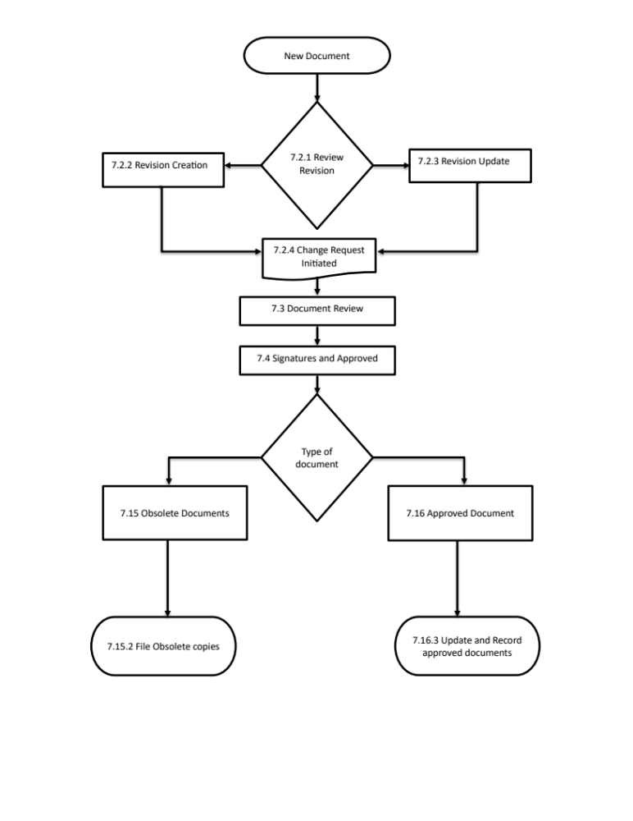
Appendix A

Notification to the FDA, Notified Body (ISO Registrar), Health Canada and/or Authorized Representative (AR)

Type of changes that may need to be reported to the following:
Changes | FDA | Notified Body  (ISO Registrar) | Health  Canada | Australia  (Sponsor) | Brazil  (BRH) | Japan  (MAH) | Authorized  Representative
Change in the location of the firm | X | X | X | X | X | X | X
Change in the ownership of the firm | X | X | X | X | X | X | X
Change in Management Representative and/or Official Correspondent | X | X | X | X | X | X | X
Change in trade name and/or reorder numbers |  | X | X | X | X | X | X
Significant changes in the Medical Devices sold in Europe under the CE Mark, including new product classifications |  | X |  |  |  |  | X
Significant changes in the Medical Devices sold in Canada (Device Licenses, Establishment Licenses, etc.) |  |  | X
Significant changes in the Medical Devices sold in the United States (510(k), Device Listing, etc.), including new or deleted products, new product classifications, and updates to Device Listing | X
Changes in US FDA Establishment type (e.g. manufacturer, specification developer, etc.) | X |  |  | X

Appendix B

- All Company Documents Responsibility Matrix
 |  | Function
 |  | Management  Representative | Vice President | Operations | Regulatory Affairs & Quality Assurance
Document Content | Documentation | X | X | X | X
Document Content | Regulatory | X | X |  | X
Document Content | Sales | X | X | X
Document Content | Marketing | X | X | X
Document Content | Production | X | X | X | X

- Read/Write Access to Controlled Documents Matrix

Job Description(s) | Employee | Read Access | Read Documents | Write Access | Write  Documents
VP | Debbie Pilkington | x | All | x | Forms, RFDs, Reports and Records
VP Regulatory Affairs | Marc Pilkington | x | All | x | Forms, RFDs, Reports and Records
RA/QA | Marc Pilkington  Salvador Iniguez | x | All | x | All Level 1, 2 and 3 Documents
Production & Inventory Control | Gary Medina | x | All | x | All Level 1, 2 and 3 Documents
Document Control Administrator | Oscar Zendejas | x | All | x | All Level 1, 2 and 3 Documents
R&D/Engineering | Marc Pilkington | x | All | x | Forms, RFDs, Reports and Records
Shipping & Receiving | Ana Frausto-Cruz | x | All | x | Forms, RFDs, Reports and Records

III Review/Approval of Controlled Documents Matrix

Level | Document | Management | VPRA | Quality Assurance | Regulatory Affairs | Engineering | Production
1 | Quality Manual | A | A, D, R, rT | rT | cT, rT | rT | rT
2 | Quality System Procedures | A | A, D, R, rT | rT | D, cT, rT | rT | rT
3 | Product Specifications | A | A, D, R, rT | A, D, rT | A, D, cT, rT | D, rT | rT
4 | Drawings | A | A, D, R, rT | A | A | A, D, rT | rT
4 | Labeling | A | A, D, rT | D | D | D | rT
4 | Work Instructions | A | A, D, R, rT | R, rT | cT, rT | rT | rT, cT, R, D
4 | Records (RFD, forms, tags charts) | A | A, D, R, rT | R, rT | R, rT | D, rT | R, rT, cT, D
A = Approves
D = Drafts/Designs/Initiates
R = Revises
rT = Receives Training
cT = Conducts Training

